**Characteristics of Life**[1]

Biology is the study of living things. In this activity, you will learn about the characteristics of living things.

**1.** To begin, write down the characteristics that you think distinguish living things from non-living things. What characteristics are shared by all types of living things, including bacteria, plants and animals?

Next, you will view two videos, both entitled “Characteristics of Life”. The first video is simpler and provides a useful introduction. View this video at <https://www.youtube.com/watch?v=0NnFhY_STFQ>.

**2.** In this table, name and give examples of as many characteristics of life as you can remember from the video.

|  |  |
| --- | --- |
| **Characteristics of Living Things** | **Examples** |
|  |  |
|  |  |
|  |  |
|  |  |
|  |  |
|  |  |
|  |  |

The second video provides more information about the characteristics of life and introduces some problems that biologists encounter as they try to decide what is living and what is non-living. View this video at <https://www.youtube.com/watch?v=cQPVXrV0GNA>.

**3.** After you watch this video, complete the table in question 2.

**4a**. Describe examples of non-living things that have one or more of these characteristics of life.

**4b**. If some non-living things have some of the characteristics of life, how can we distinguish these non-living things from living things?

**5**. Each figure in this question illustrates at least two of the characteristics of life. For each figure, write sentences that explain how the figure illustrates two or more characteristics of life.

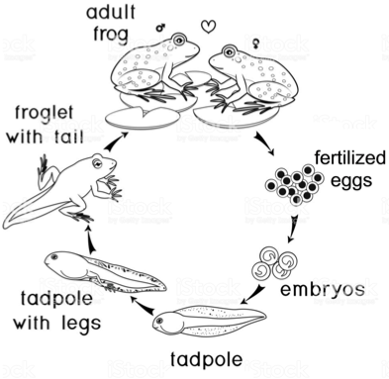

-----------------------------------------------------------------------------------------------------------------------------

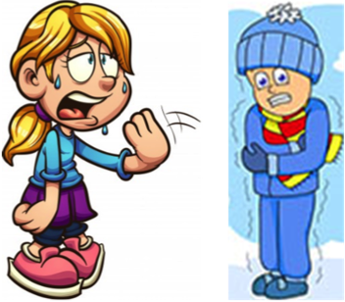

----------------------------------------------------------------------------------------------------------------------------

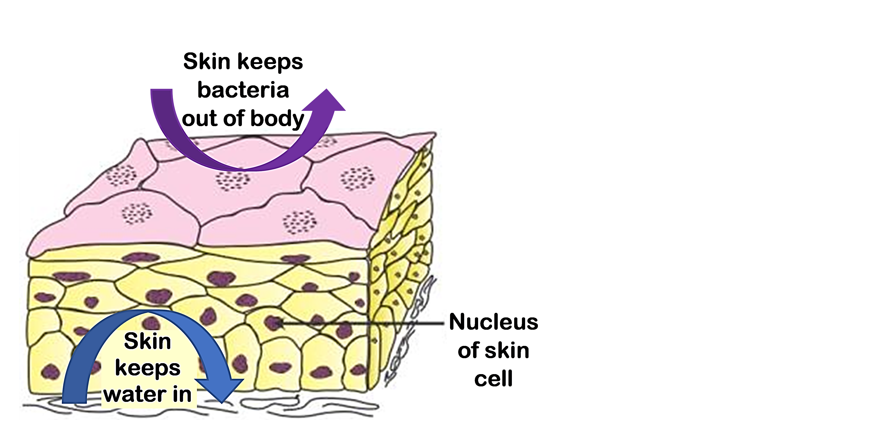

This figure shows a highly magnified view of

a cross-section of human skin. (Question 5 is continued on the next page.)

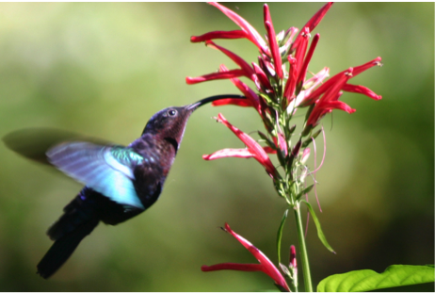

----------------------------------------------------------------------------------------------------------------------------

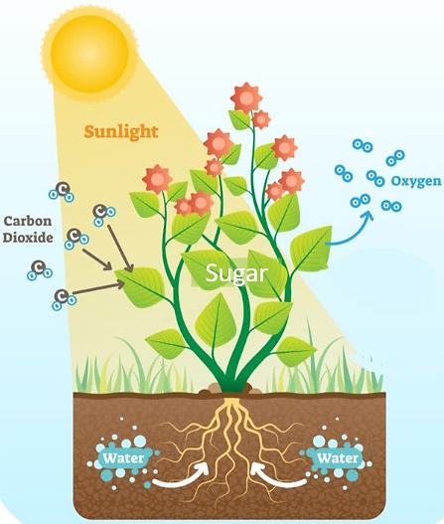

----------------------------------------------------------------------------------------------------------------------------

Some living things lack one or two of the characteristics of life. For example, a mule is the offspring of a female horse and a male donkey. Mules cannot reproduce; so, mules have not undergone evolutionary adaptation. However, mules have all the other characteristics of life, and they are universally accepted as living.

Viruses lack many of the characteristics of life. For example, viruses don’t grow, maintain homeostasis, use energy, or have cellular organization. However, viruses do have some of the characteristics of life. For example, viruses can reproduce, although only by invading a cell and using its molecules. Viruses have also evolved adaptations.

**6a**. What do you conclude about the question “Are viruses alive?”

**6b.** What does the information about mules and viruses imply for how we should distinguish between living and non-living things?

1. By Dr. Ingrid Waldron, Department of Biology, University of Pennsylvania © 2024. This Student Handout and Teacher Notes with instructional suggestions and biology background are available at [https://serendipstudio.org/exchange/bioactivities/lifecharacteristics](%20https:/serendipstudio.org/exchange/bioactivities/lifecharacteristics).